**Guidance Class Lesson for the week of May 4-8**

**Let’s learn about handling mistakes: Lesson 4**

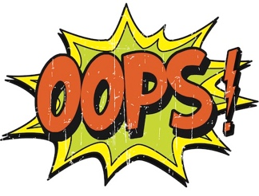

Hello Terrific 2nd graders and families! I miss you all so much!

This week we are learning about how to handle making mistakes! Every single day I make mistakes. How about you? Do you make mistakes too? Have you heard it said that nobody is perfect? Well, It’s true. No one is perfect. Sometimes it’s very frustrating to make a mistake. The most important thing to learn is how to handle making mistakes. Of course, we want to try to do our best, but when we do make a mistake we can learn from it . And maybe even laugh at ourselves too!

**Lesson 4:** **Handling mistakes**

1. Read the book, “The Girl Who never made Mistakes”

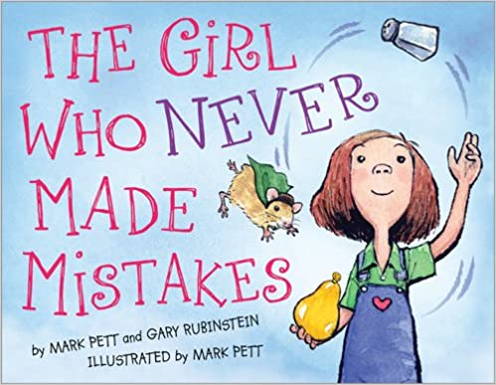

<https://youtu.be/oQG4vFGd6eU>

2.Watch the video about handling mistakes.

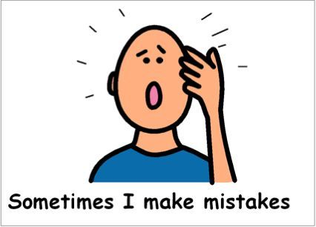

<https://youtu.be/ndvt89ybSSE>

3. Listen to this song about making mistakes when you are learning.



<https://youtu.be/e5R_l23XdWk>

4. Here are 2 activities to print about making mistakes. [Learning from mistakes](Mistakes%20activity), and [At school](MakingMistakes%20web.pdf)